Vagrant was not authenticating I fixed it ……………………..now it looks like this

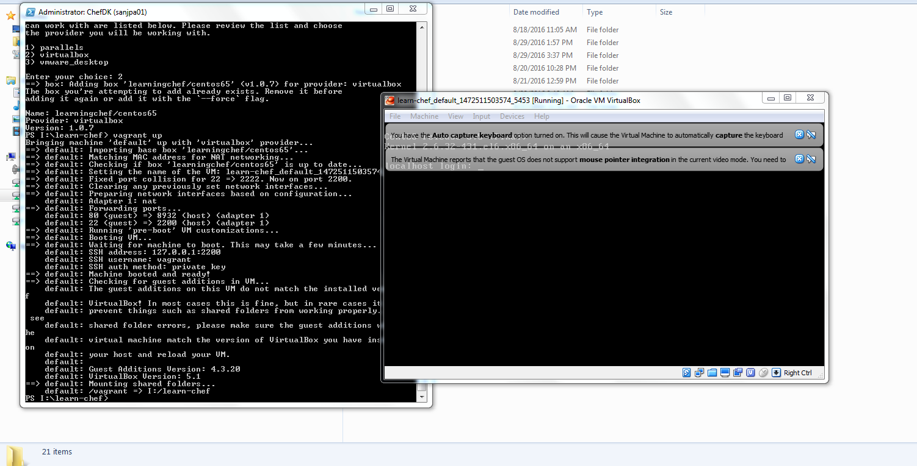

Usefull link is <https://www.vagrantup.com/docs/getting-started/up.html>

With following vagrantfile configuration

###################################################################################

# -*- mode: ruby -*-

# vi: set ft=ruby :

# All Vagrant configuration is done below. The "2" in Vagrant.configure

# configures the configuration version (we support older styles for

# backwards compatibility). Please don't change it unless you know what

# you're doing.

Vagrant.configure("2") do |config|

# The most common configuration options are documented and commented below.

# For a complete reference, please see the online documentation at

# https://docs.vagrantup.com.

# Every Vagrant development environment requires a box. You can search for

# boxes at https://atlas.hashicorp.com/search.

config.vm.box = "learningchef/centos65"

# Disable automatic box update checking. If you disable this, then

# boxes will only be checked for updates when the user runs

# `vagrant box outdated`. This is not recommended.

# config.vm.box_check_update = false

# Create a forwarded port mapping which allows access to a specific port

# within the machine from a port on the host machine. In the example below,

# accessing "localhost:8080" will access port 80 on the guest machine.

config.vm.network "forwarded_port", guest:80, host:8932, auto_correct:true

# Create a private network, which allows host-only access to the machine

# using a specific IP.

# config.vm.network "private_network", ip: "192.168.33.10"

# Create a public network, which generally matched to bridged network.

# Bridged networks make the machine appear as another physical device on

# your network.

# config.vm.network "public_network"

# Share an additional folder to the guest VM. The first argument is

# the path on the host to the actual folder. The second argument is

# the path on the guest to mount the folder. And the optional third

# argument is a set of non-required options.

# config.vm.synced_folder "../data", "/vagrant_data"

# Provider-specific configuration so you can fine-tune various

# backing providers for Vagrant. These expose provider-specific options.

# Example for VirtualBox:

#

config.vm.provider "virtualbox" do |vb|

# # Display the VirtualBox GUI when booting the machine

vb.gui = true

#

# # Customize the amount of memory on the VM:

vb.memory = "1024"

end

#

# View the documentation for the provider you are using for more

# information on available options.

# Define a Vagrant Push strategy for pushing to Atlas. Other push strategies

# such as FTP and Heroku are also available. See the documentation at

# https://docs.vagrantup.com/v2/push/atlas.html for more information.

# config.push.define "atlas" do |push|

# push.app = "YOUR_ATLAS_USERNAME/YOUR_APPLICATION_NAME"

# end

#config.ssh.username = 'vagrant'

#config.ssh.password = 'vagrant'

#config.ssh.insert_key = 'true'

config.ssh.insert_key = false

# Enable provisioning with a shell script. Additional provisioners such as

# Puppet, Chef, Ansible, Salt, and Docker are also available. Please see the

# documentation for more information about their specific syntax and use.

# config.vm.provision "shell", inline: <<-SHELL

# apt-get update

# apt-get install -y apache2

# SHELL

End

#######################################################################

